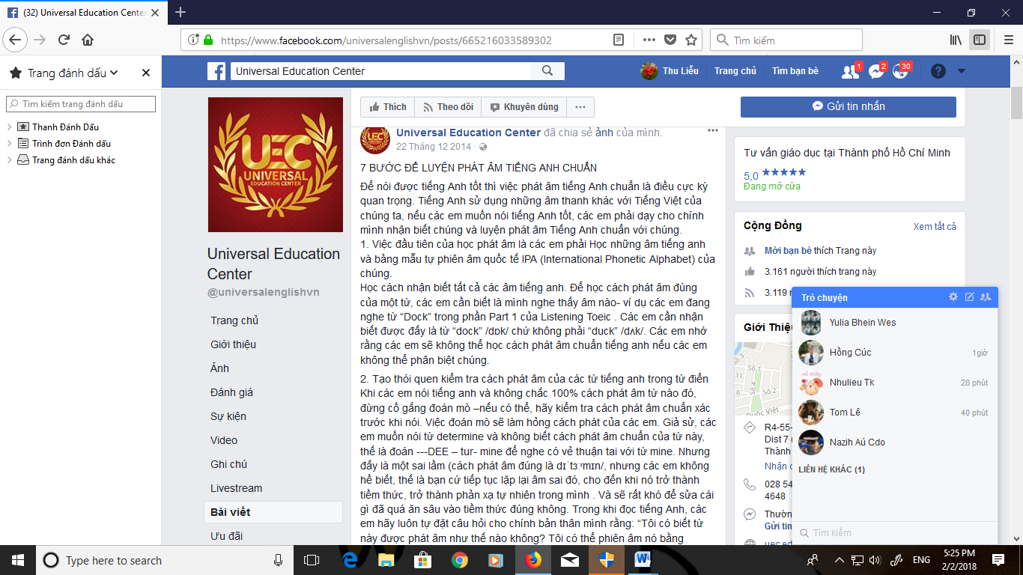
https://www.facebook.com/universalenglishvn/posts/665216033589302
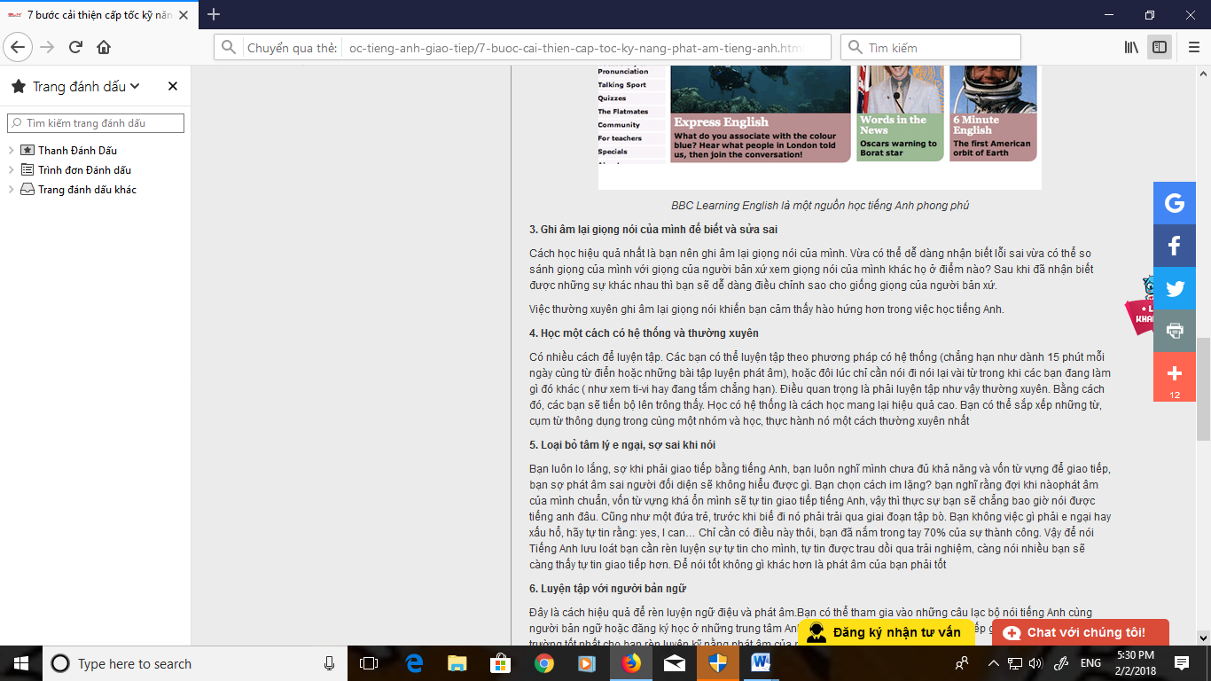
https://gln.edu.vn/tieng-anh-giao-tiep-nguoi-lon/vi/phuong-phap-hoc-tieng-anh-giao-tiep/7-buoc-cai-thien-cap-toc-ky-nang-phat-am-tieng-anh.html
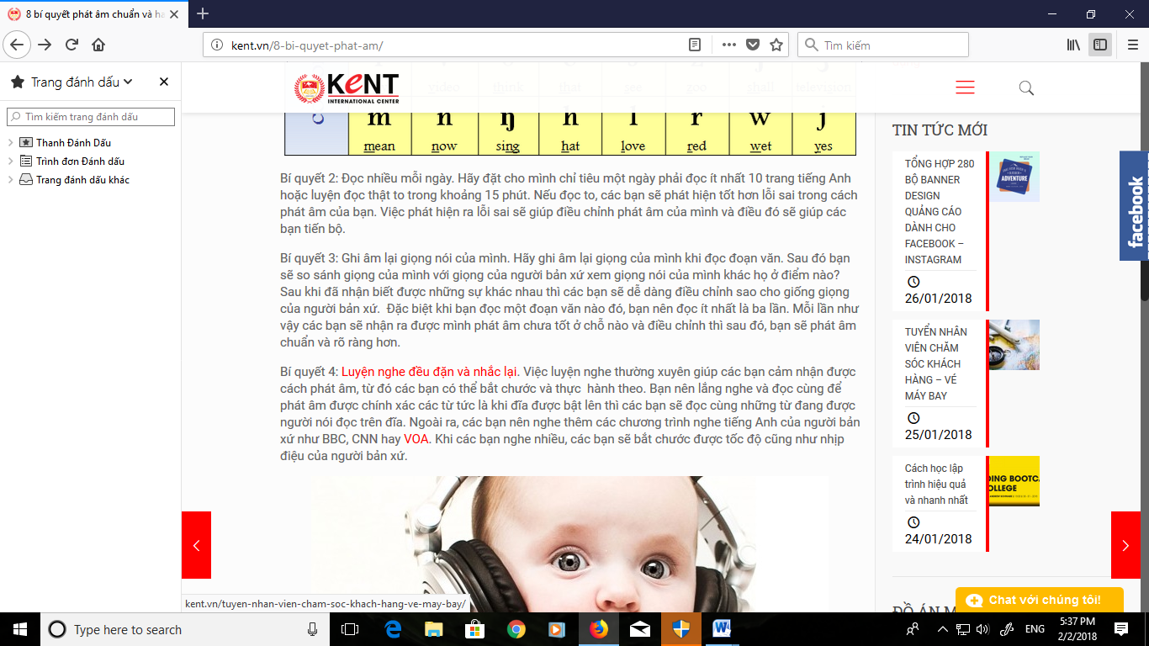
http://kent.vn/8-bi-quyet-phat-am/

